

**Plastic Baggie**



**Lunch Tray**



**Empty Milk Carton**



**Milk Pouch**

**& Straw**



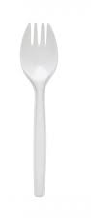

**Straw**

**Spork**

**Napkins**

**N**

**Spork wrapper, straw,& napkin**

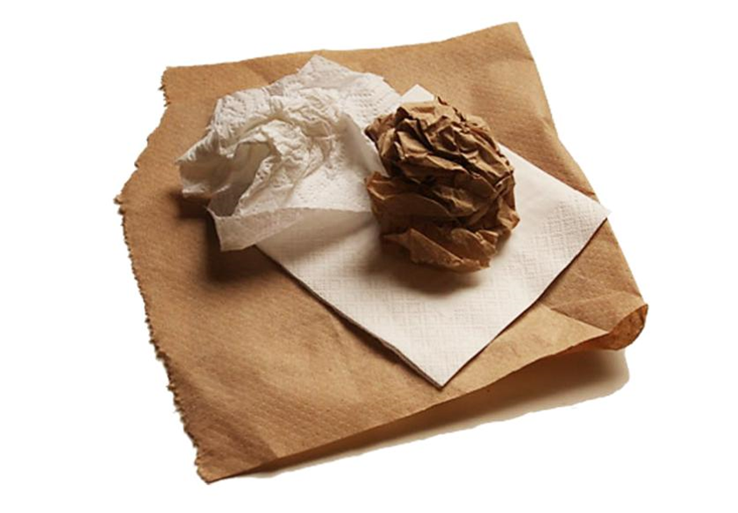

**Napkins**

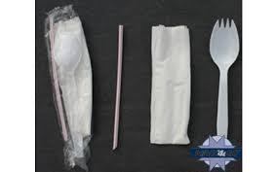

**Lunchables Box**

**Plastic Lunchables Tray**

**Set 5**

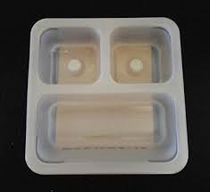

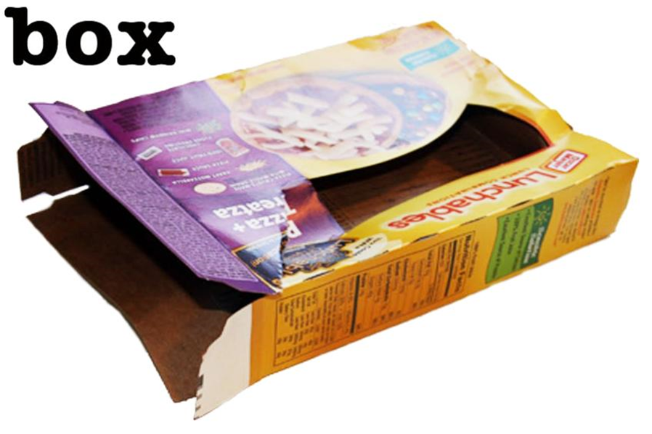

**Empty Fruit Cup**

**Plastic Fruit Cup**

**Top**

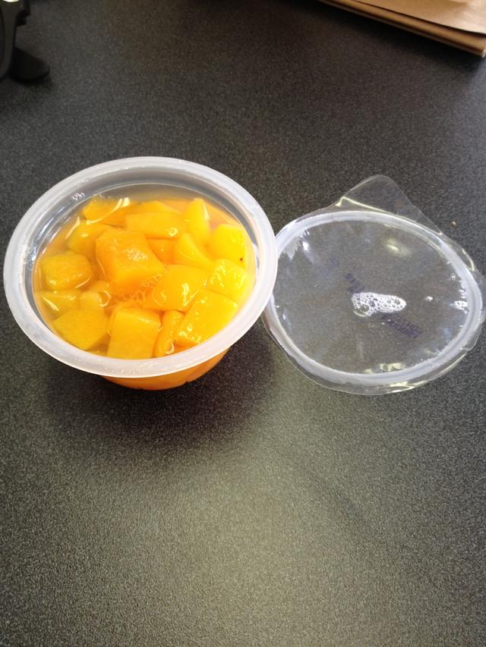

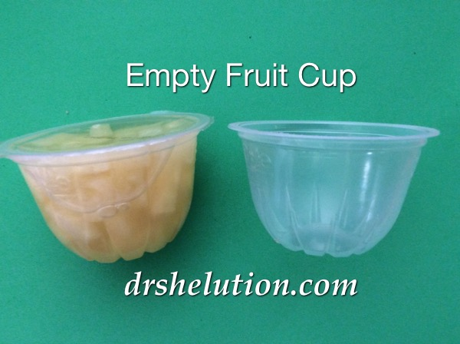

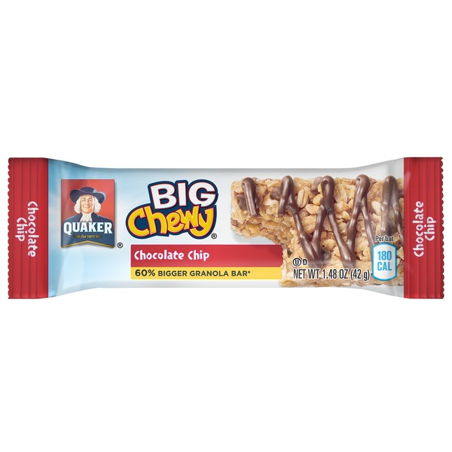

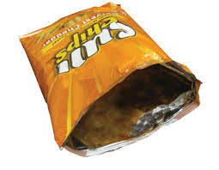

**Food Wrapper**

**Chip Bag**

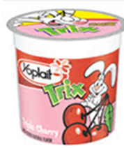

**Empty Yogurt Cup & Foil Lid**

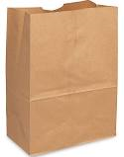

**Paper Bag**

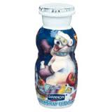

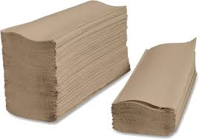

**Empty Plastic Seaweed Container**

**Empty Plastic Container**

**Empty Plastic Yogurt Drink Bottle**

**Paper Towels**

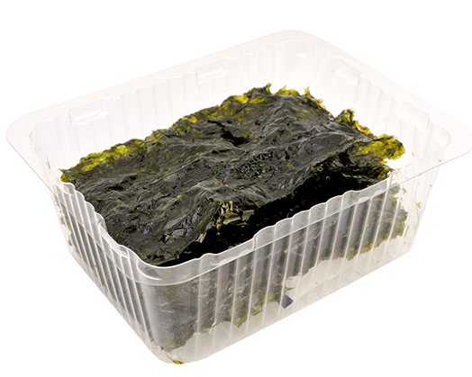

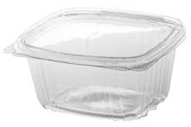

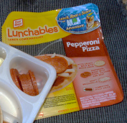

**Empty Juice Box**

**Slush Drink Pouch**

**Lunchables Plastic Top**

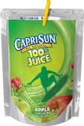

**Juice Pouch**

**& Straw**

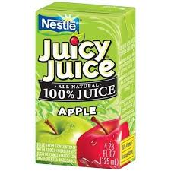

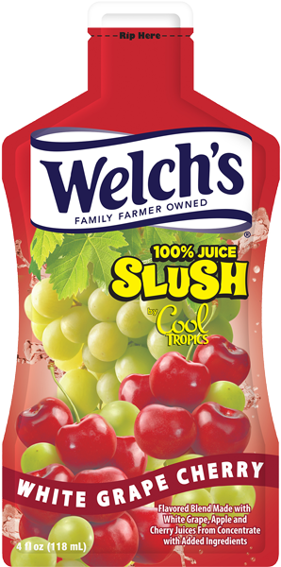



**Eels**